Candidate_Result_vw

Phase1

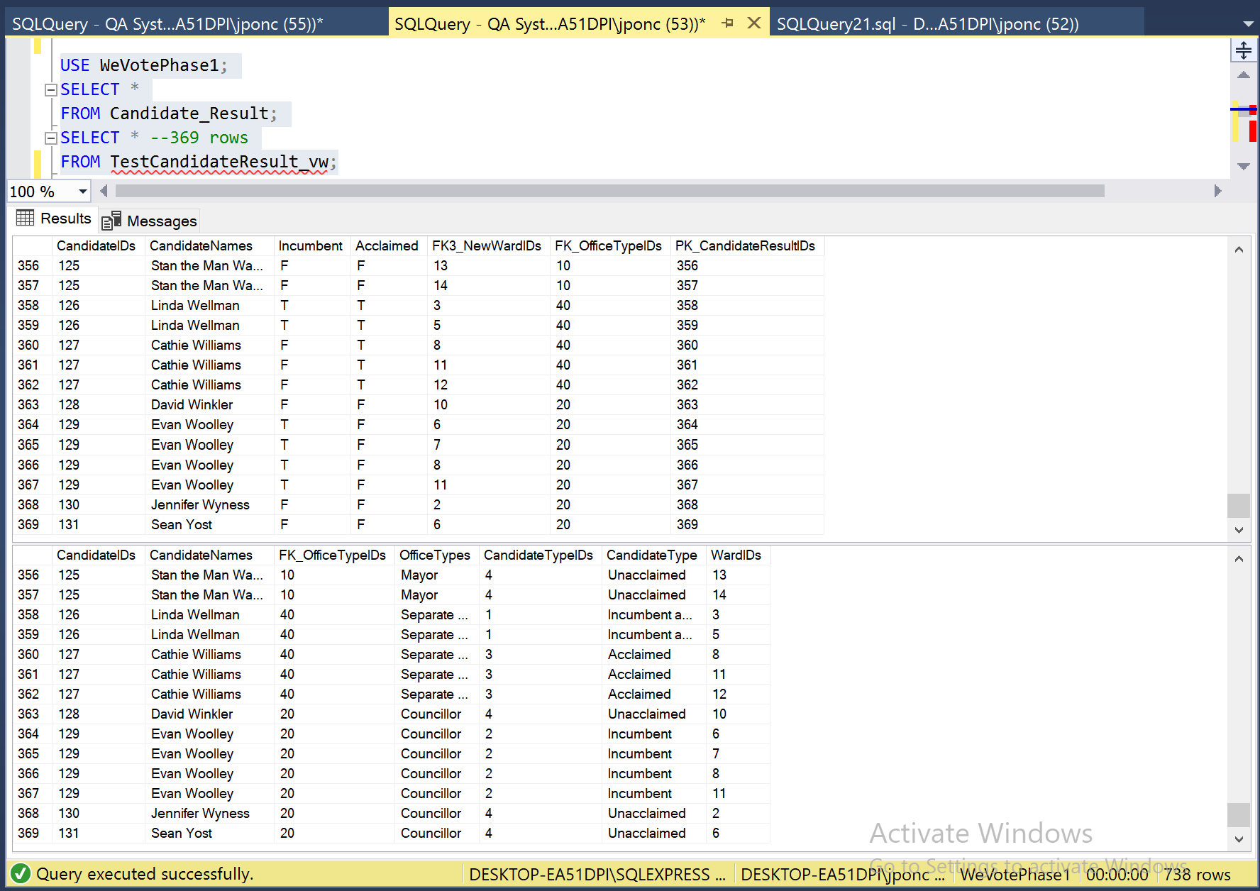

CREATE VIEW TestCandidateResult_vw AS(

SELECT a.CandidateIDs,

b.CandidateNames,

a.FK_OfficeTypeIDs,

c.OfficeTypes,

d.CandidateTypeIDs,

d.CandidateType,

a.FK3_NewWardIDs AS WardIDs

FROM Candidate_Result a

INNER JOIN CandidateName b ON a.CandidateIDs=b.PK_CandidateIDs

INNER JOIN OfficeType AS c ON a.FK_OfficeTypeIDs=c.PK_OfficeTypeIDs

INNER JOIN TestCandidateType AS d ON (a.Incumbent=d.Incumbent AND a.Acclaimed=d.Acclaimed));

DROP VIEW TestCandidateResult_vw;

Related Issue - #64 CandidateType table

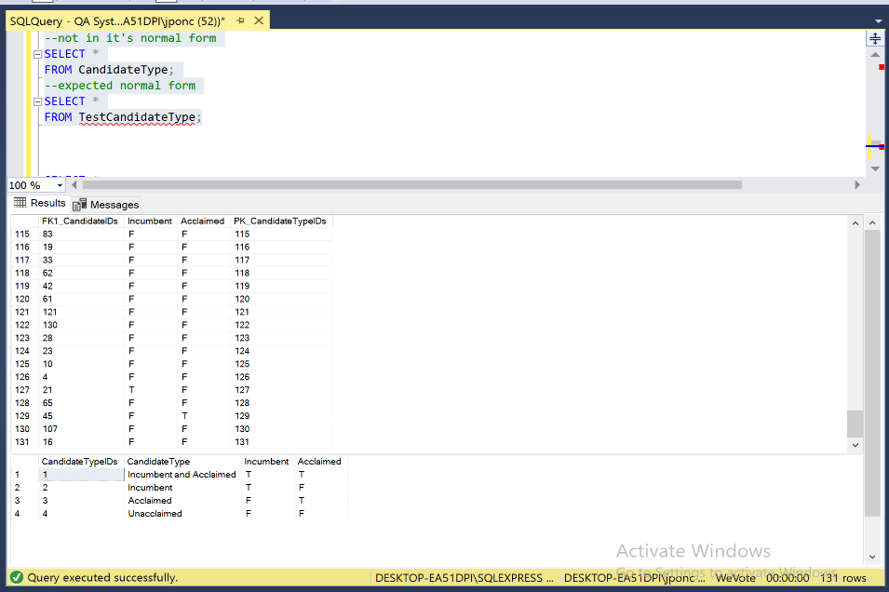

Phase2

